*Nested Loops Practice*

*Pattern Builder Lab*

# Main Objectives

* Build a skillset to manipulate 2d arrays using nested loops.
* Logic building.

# Prior Knowledge

Students need to know how to write basic nested loops and will build upon that knowledge with these exercises. Students need to know how to build 2d arrays, access and modify individual elements, and determine the number of rows and columns of the 2d array. The project needs no knowledge of Greenfoot, all Greenfoot requirements have been pre-set up so students can focus purely on the 2d array manipulation.

# Getting Started

Install the Greenfoot IDE: <https://www.greenfoot.org/download>

* Greenfoot went through many changes beginning with the 3.0.0 release. Version 2.4.2, although older, tends to be one of the most stable versions but is missing a few of the newer additions.

In your Pattern Builder folder, run the project file with the Greenfoot icon to begin.

After hitting the run button in Greenfoot, each exercise can be tested by typing the exercise key(s) on the keyboard, ie: A, B, C, H1, H2, etcetera.

# Demonstration

View a sample demonstration of what the Pattern Builder lab could look like here:

<https://www.greenfoot.org/scenarios/23754>

# Student Goals

Each part of this lab is a separate exercise in building a specific picture by placing Walls on the screen using loops. Students are given a HEIGHT variable and a WIDTH variable to represent the current screen size. The questions are not in order of difficulty and not all require nested loops. Students will need to think through the necessary requirements to build each pattern.

* Additional Challenge: Avoid adding two Walls in the same location.

## A – allMiddle. Build Walls on all areas except the outer border.

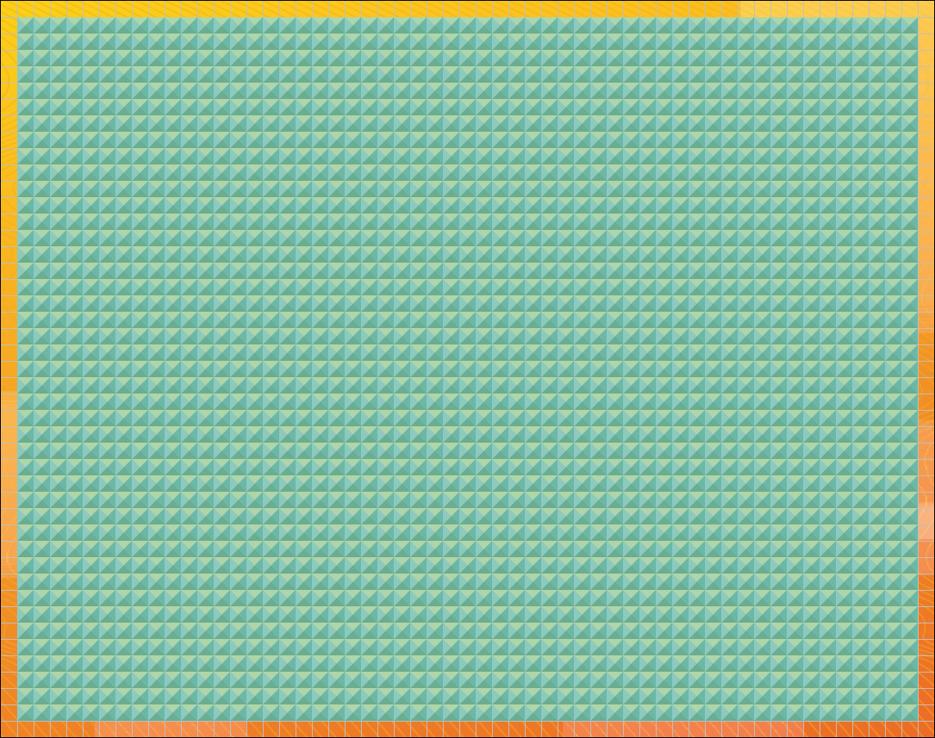

## B – border. Build Walls on only the outer border.

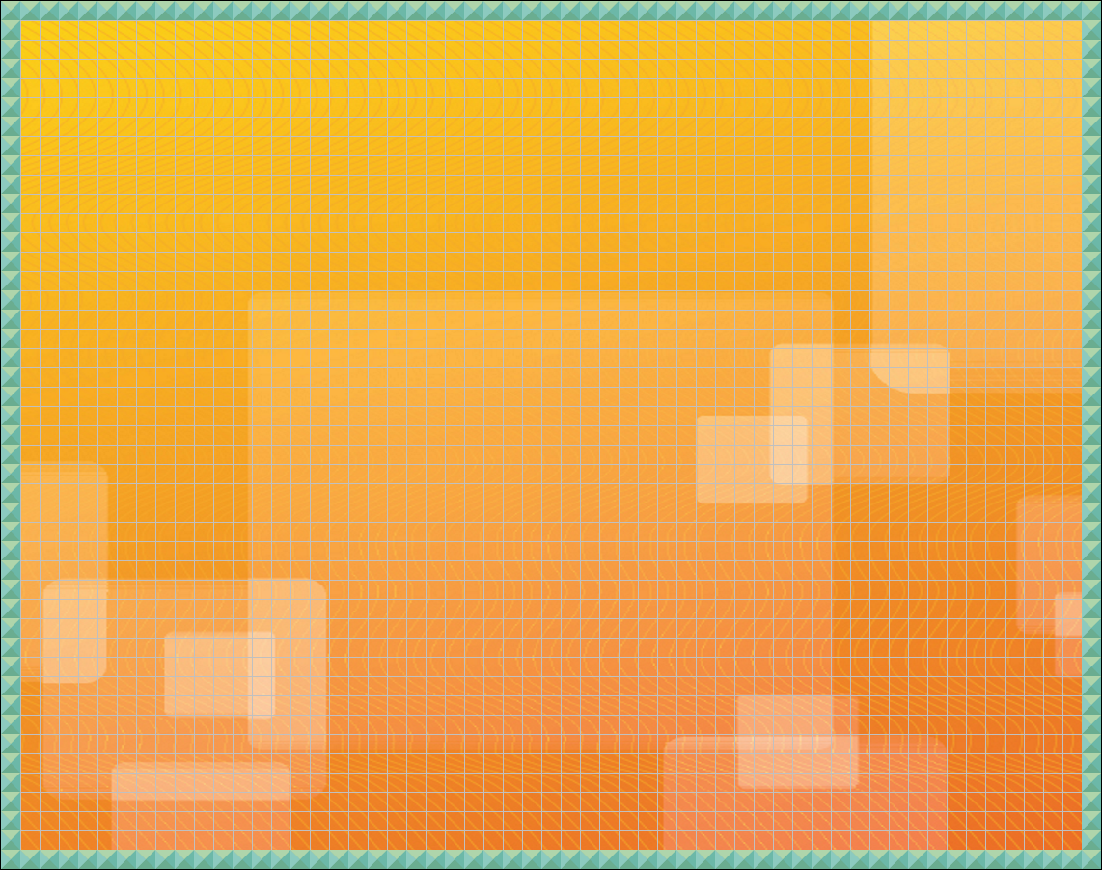

## C – checkered. Build walls on every other location to form a checker pattern.

## 

## D – diagonals. Build walls on two diagonal lines to form an X. The logic can be tricky if you want it to work on all sized worlds.

## 

## E – exterior. Use the distance formula to build walls that are further away from the center of the screen than half the height or width (radius of a circle).

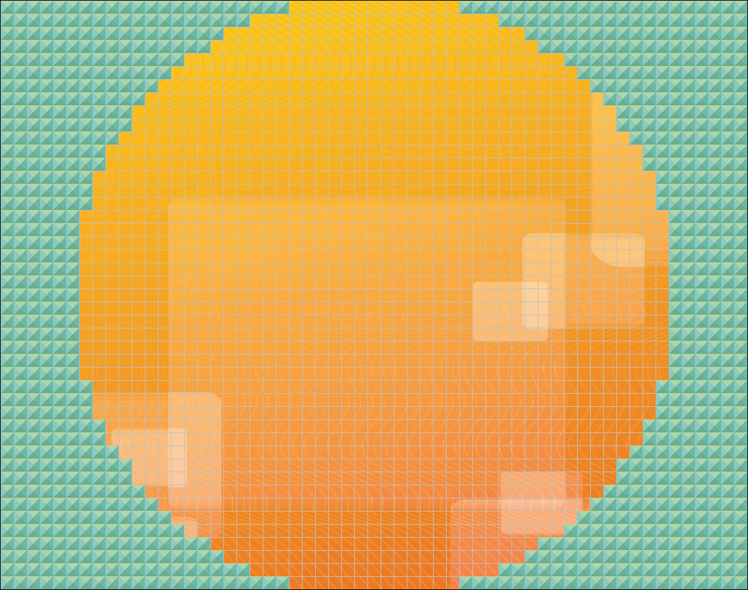

## F – fibonacci. Build Walls with the first two rows starting with only 1 Wall each, then every row afterwards will have the sum of the previous two row’s number of Walls. Due to the Fibonacci sequence growing so quickly skip some rows between.

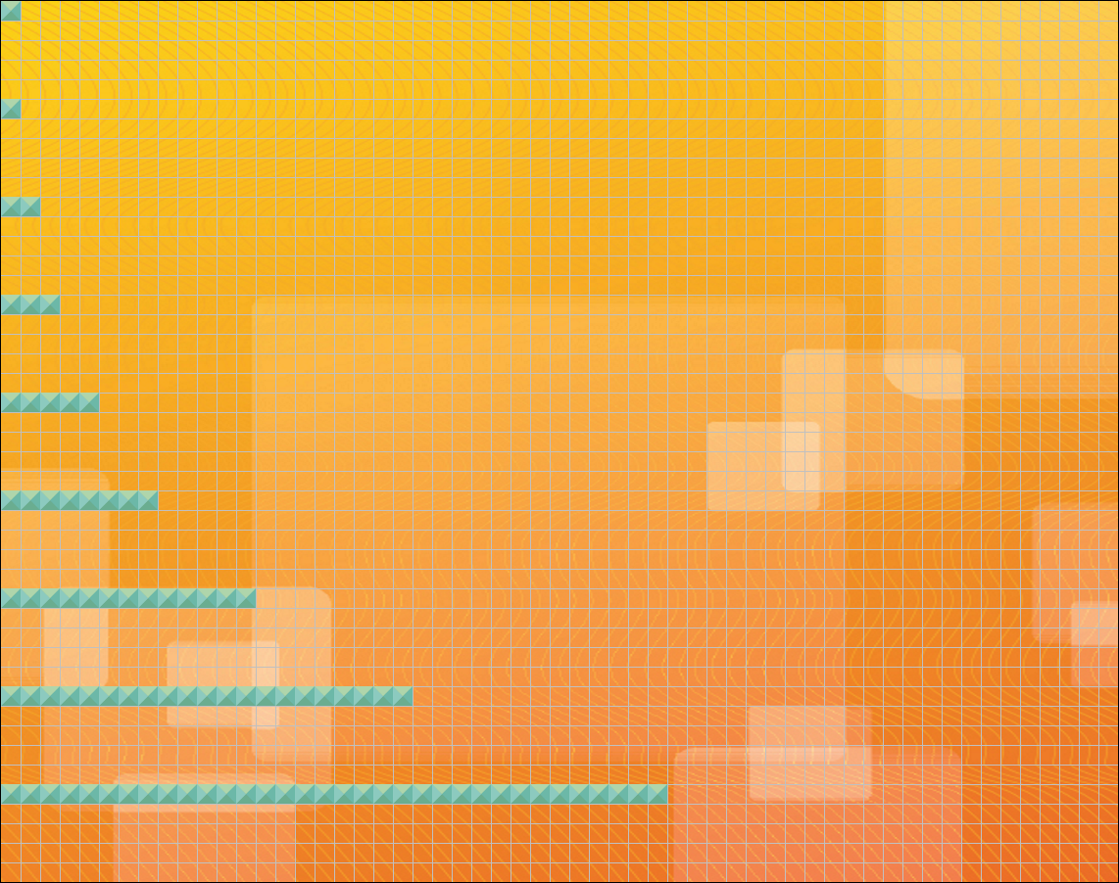

## G – geometricSeries. Build Walls with the first row having only 1 Wall and each subsequent row having twice as many Walls as the last. Due to how fast these numbers grow skip some rows between.

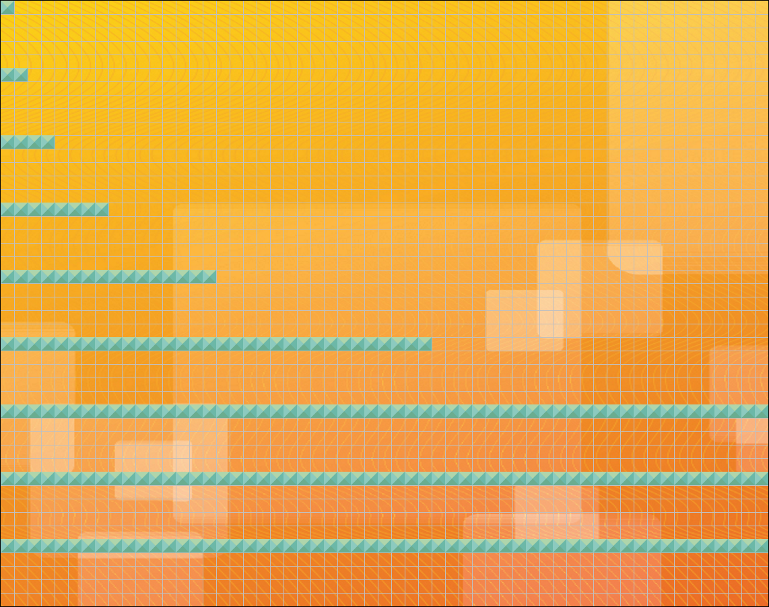

## H1 – hemisphereLeft. Build Walls to cover the left half of the World.

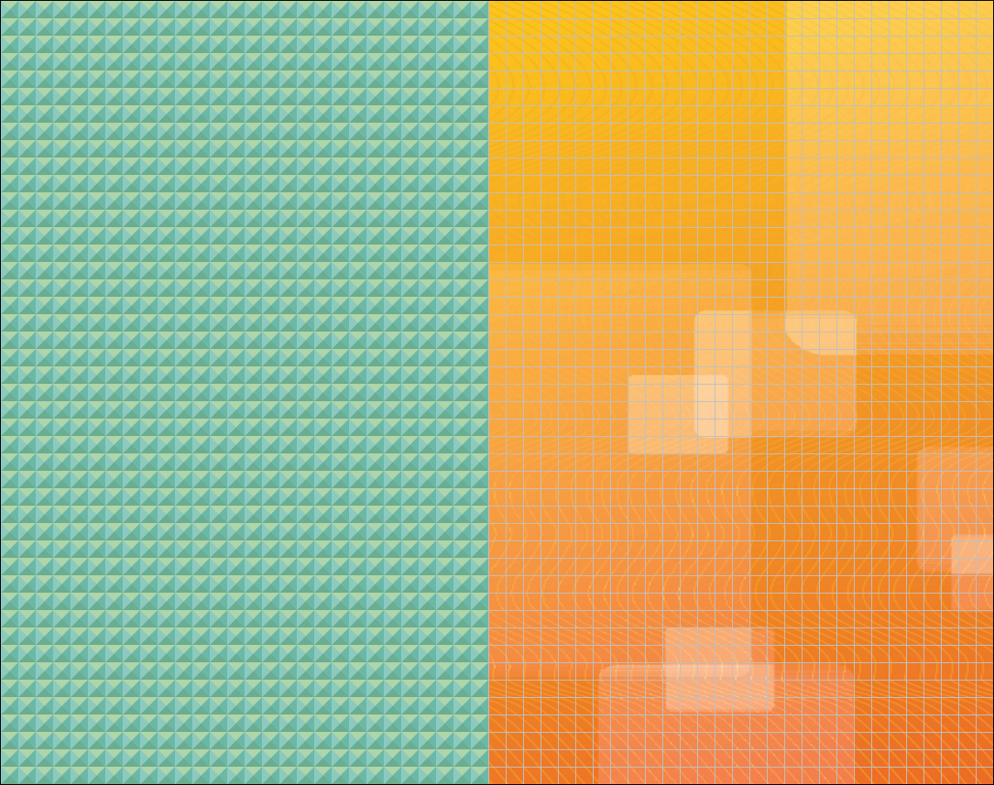

## H2 – hemisphereRight. Build Walls to cover the right half of the World.

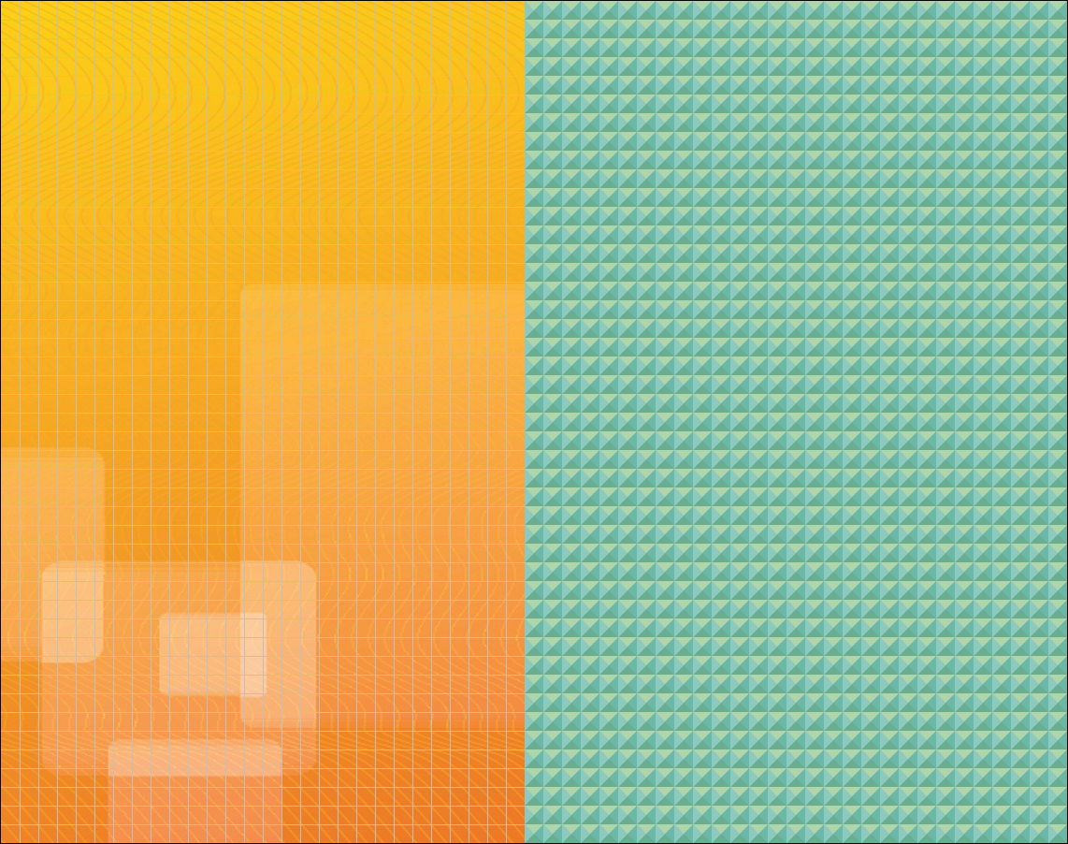

## H3 – hemisphereTop. Build Walls to cover the top half of the World.

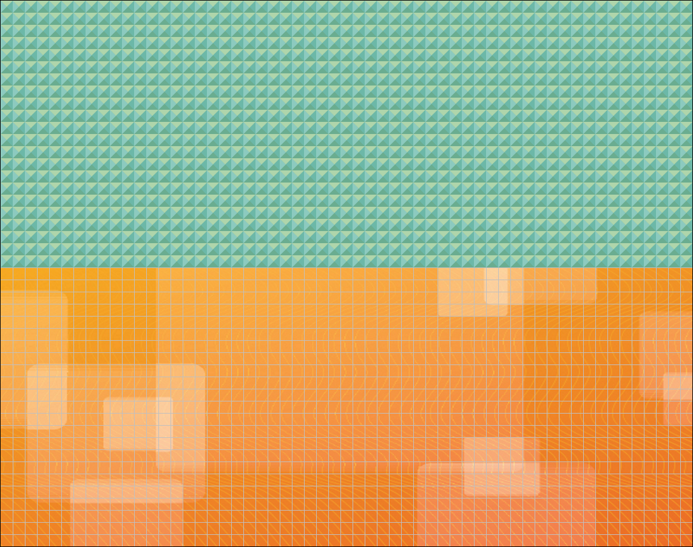

## H4 – hemisphereBottom. Build Walls to cover the bottom half of the World.

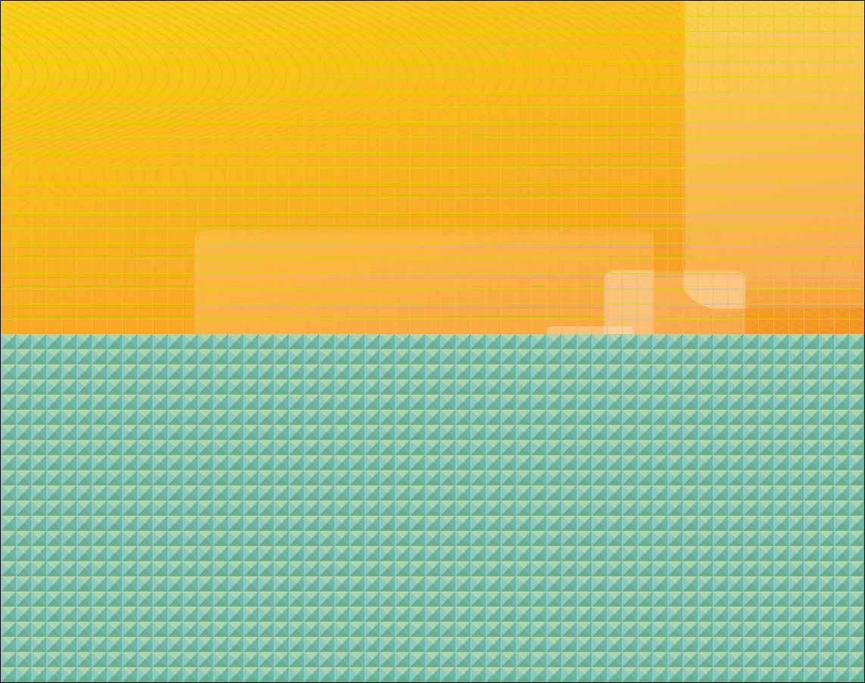

## I1 – isoscelesRightA. Build Walls to build a right isosceles triangle with the hypotenuse on the bottom right, center the triangle.

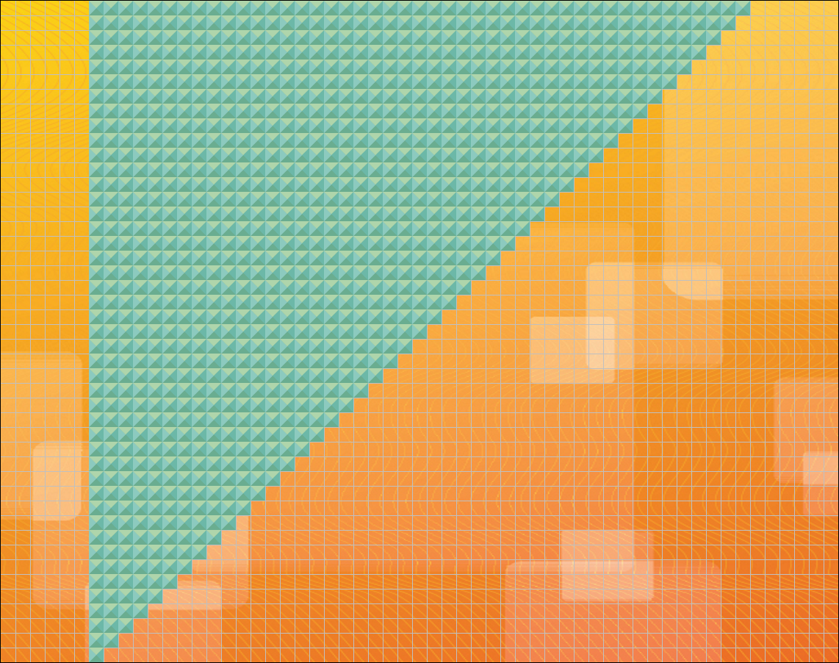

## I2 – isoscelesRightB. Build Walls to build a right isosceles triangle with the hypotenuse on the bottom left, center the triangle.

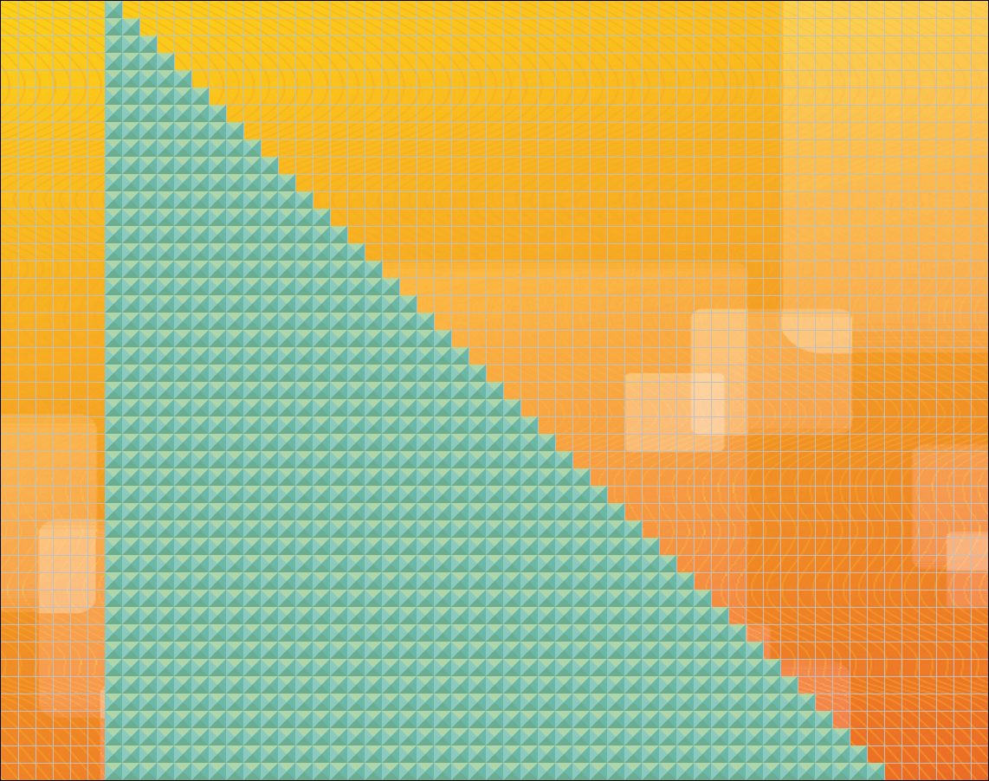

## I3 – isoscelesRightC. Build Walls to build a right isosceles triangle with the hypotenuse on the top right, center the triangle.

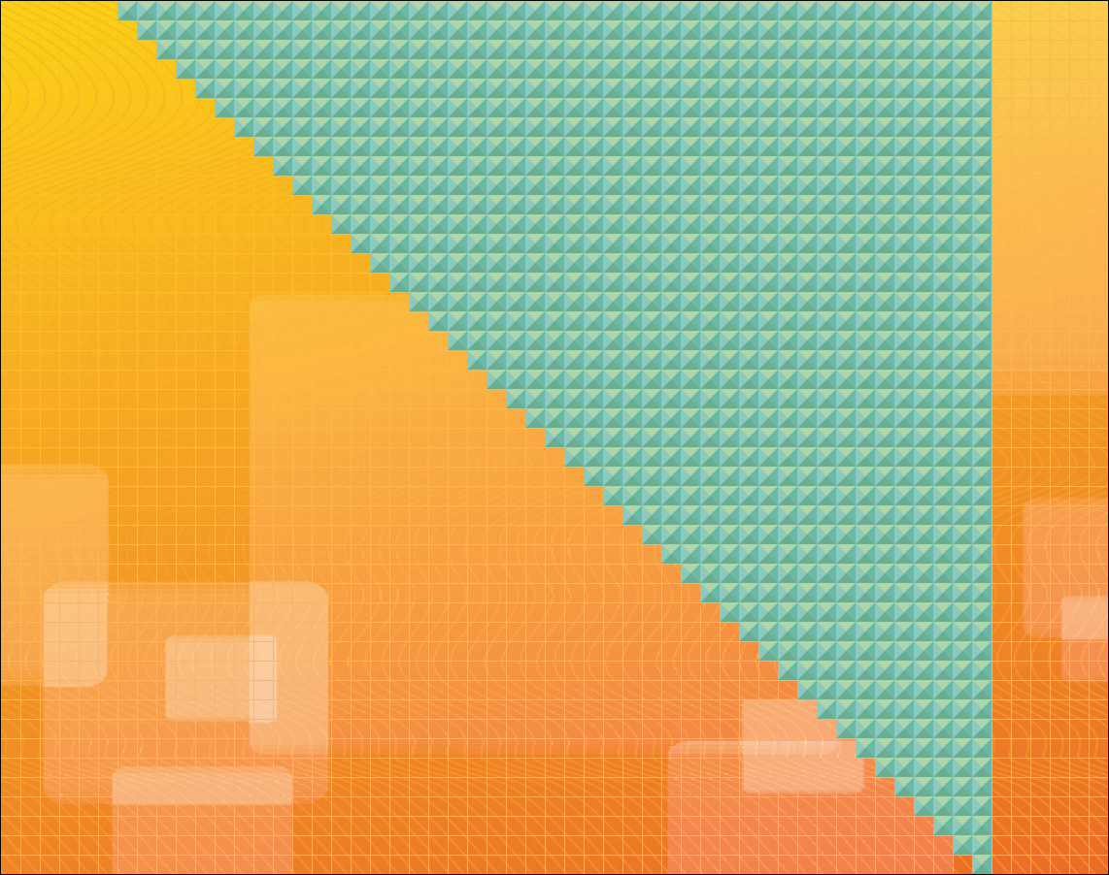

## I4 – isoscelesRightD. Build Walls to build a right isosceles triangle with the hypotenuse on the top left, center the triangle.

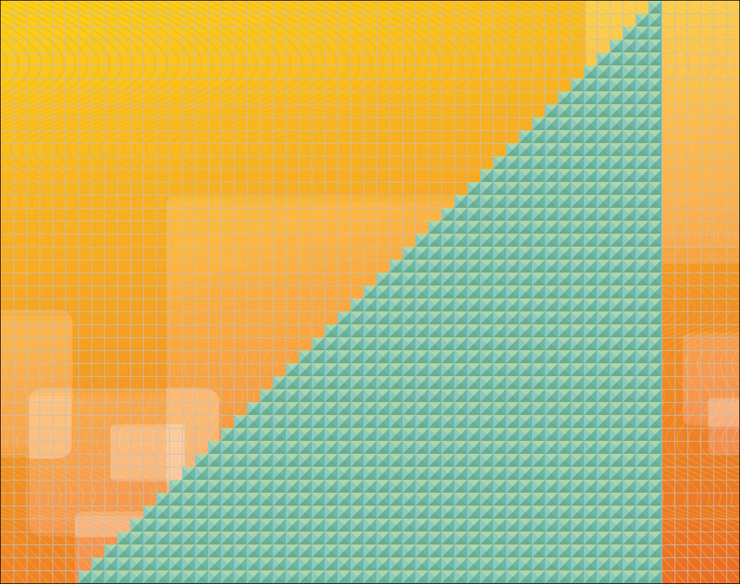

## J – jaggedSteps. Build Walls to make steps alternating either the ending missing a Wall or the beginning missing a Wall on each row.

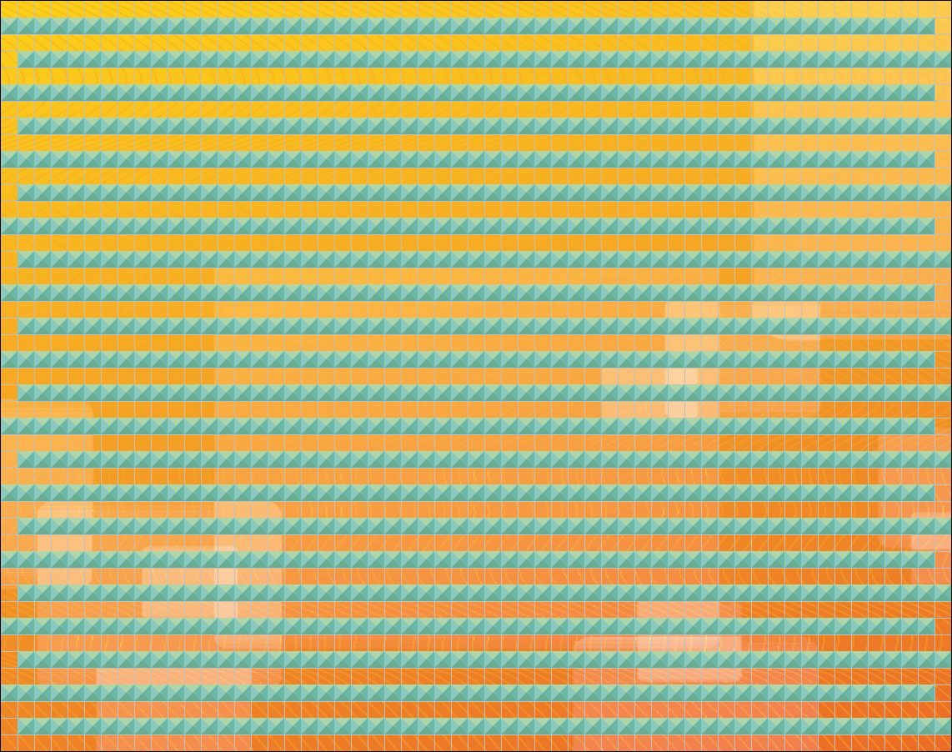

## K – knitting. Build Walls to make a knitting pattern, with sections of 3 Walls horizontal, then disappearing for three steps, before reappearing, and different sections of 3 Walls going vertical, disappearing for three steps, then reappearing.

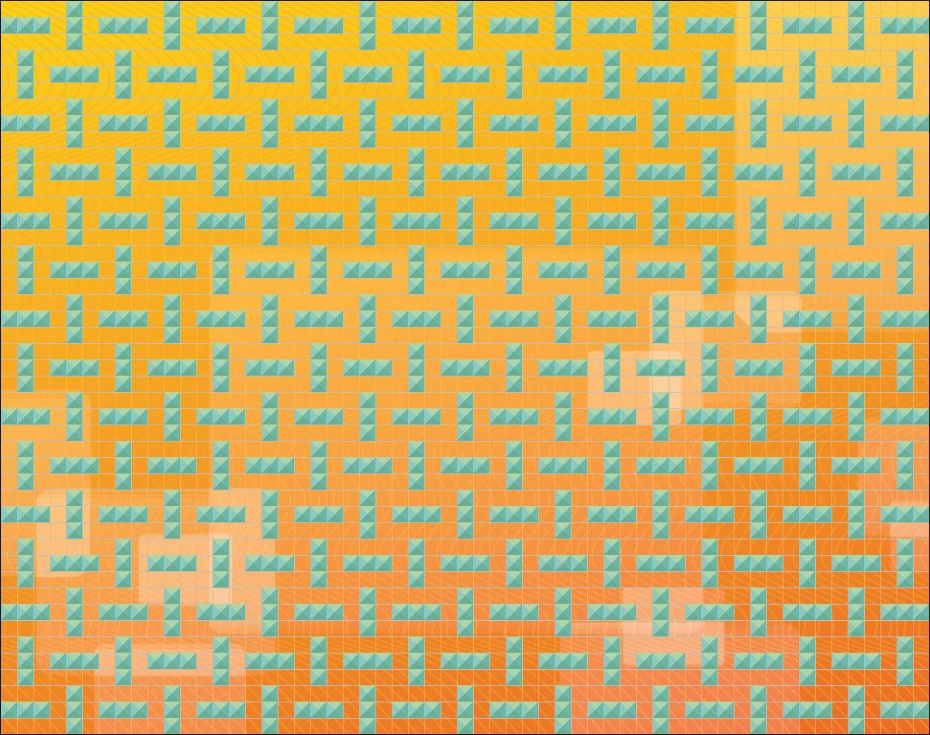

## L1 – latitudes – Draw horizontal lines of Walls skipping rows between.

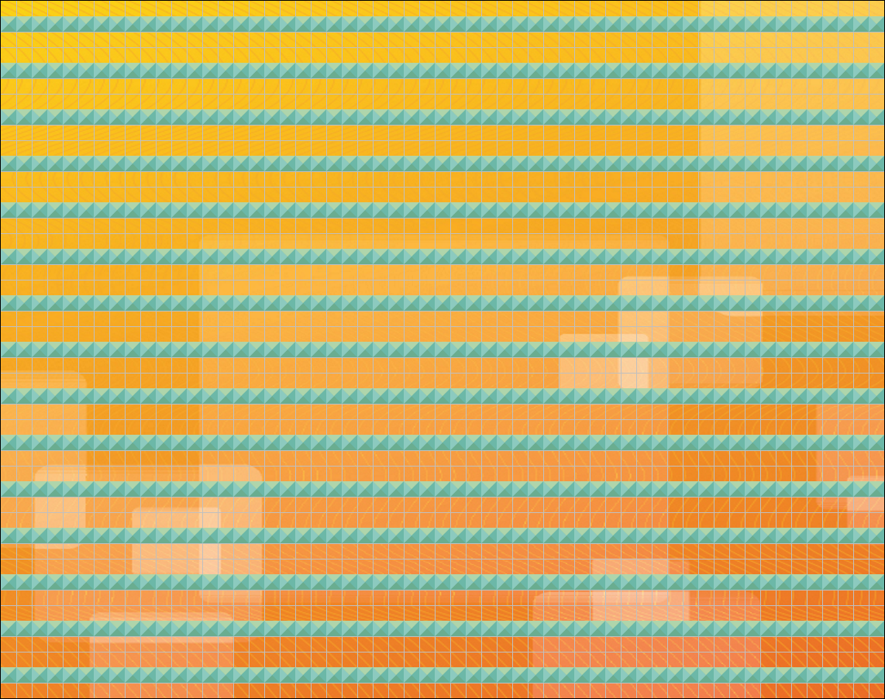

## L2 – longitudes – Draw vertical lines of Walls skipping columns between.

